Git setup

# GitHub login:

User: intruder01

Email: [Intruder01junk@hotmail.com](mailto:Intruder01junk@hotmail.com)

Pswd: gJb01

openHTM Repo URL: <https://github.com/intruder01/20150724.git>

# Create Rep o on GitHub

## Create Repository

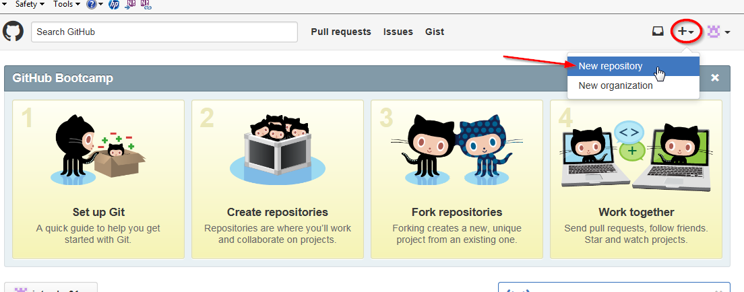

## Select Repo

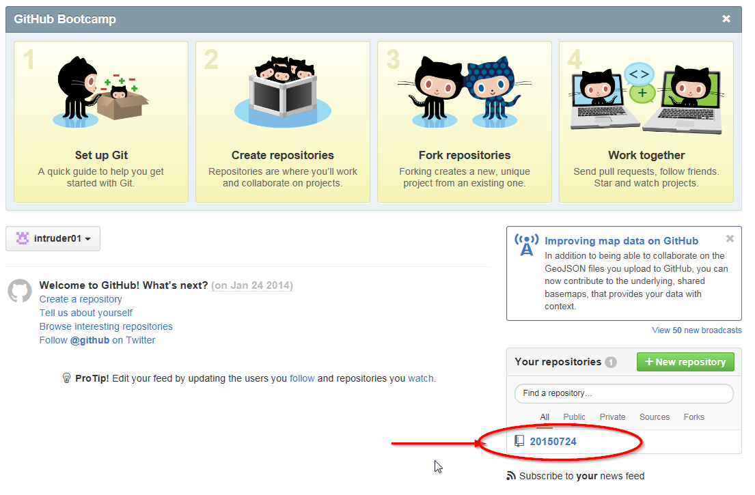

## Copy Repo URL

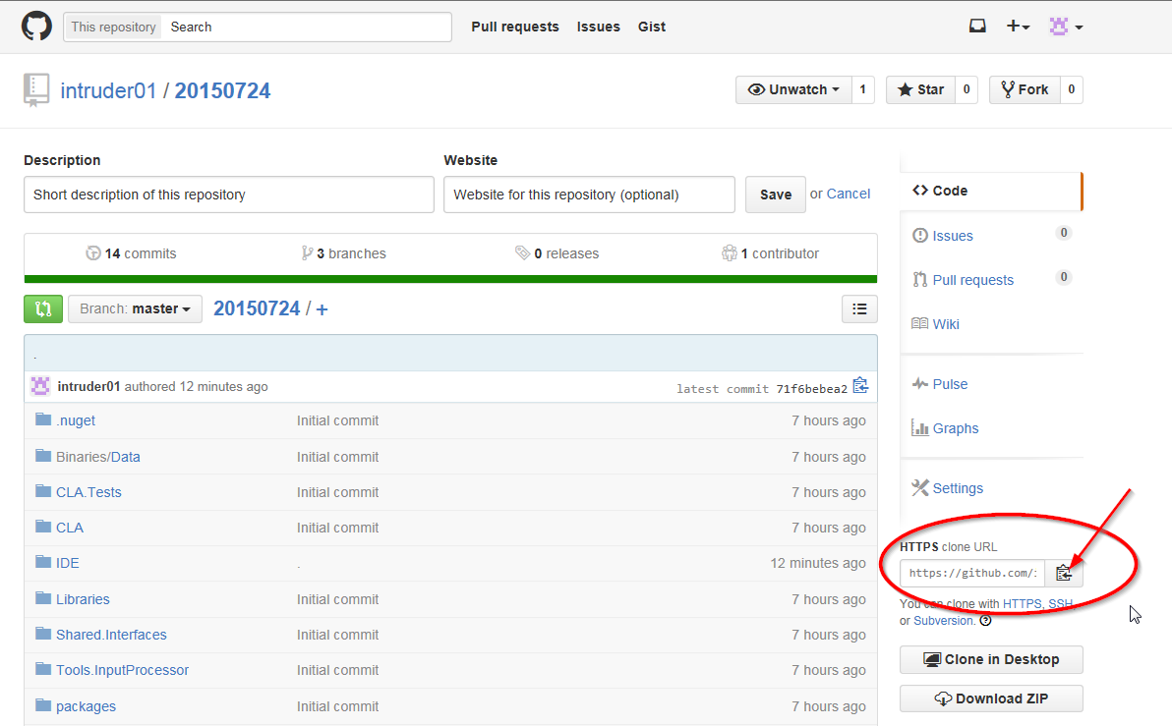

# Add Project to Git Server

## Create local Repository

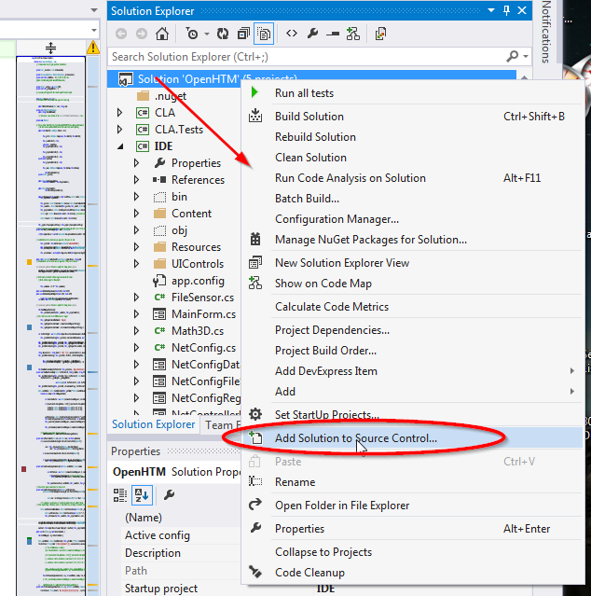

Select Git

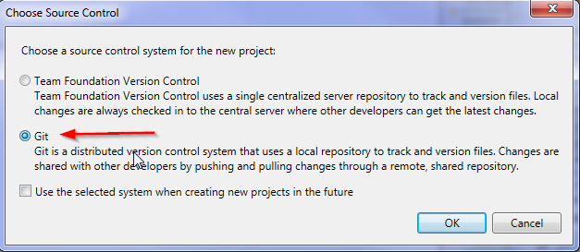

This creates .git folder in the project:

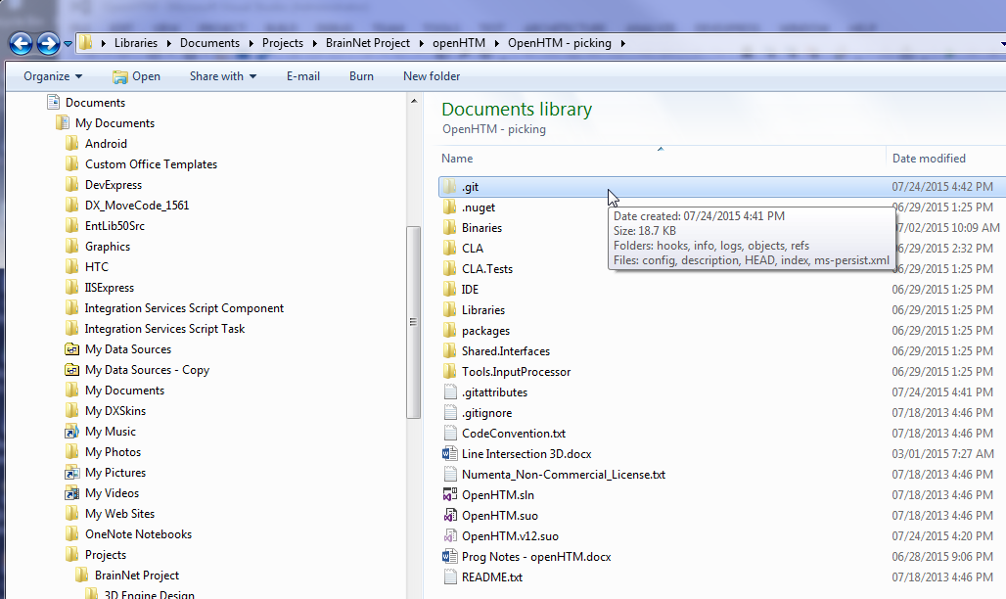

## Sync to Server

At this point, the project should show up in Team Explorer tab:

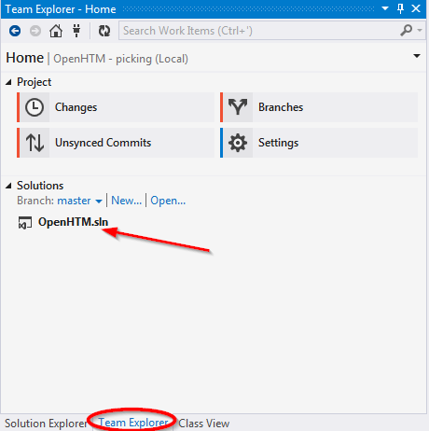

Select Changes: The whole project (all files) should show up as changed:

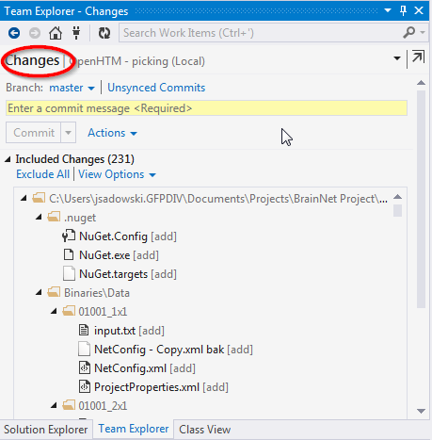

Enter commit message, press Commit btn:

